***Dt : 22/9/2022***

***Assignment:(Solution)***

***wap to read multiple strings using Arrays and display as follows:***

***(Display the String in reverse which started with Vowel)***

***DemoArray4.java***

***package maccess;***

***import java.util.*;***

***public class DemoArray4 {***

***public static void main(String[] args) {***

***Scanner s = new Scanner(System.in);***

***System.out.println***

***("Enter the size of Array to hold String Objects:");***

***int n = Integer.parseInt(s.nextLine());***

***String a[] = new String[n];//Array Object***

***System.out.println("Enter "+n+" String Objects:");***

***for(int i=0;i<=n-1;i++)***

***{***

***a[i] = new String(s.nextLine());***

***//Adding String object to Array***

***}//end of loop***

***System.out.println("====Extend for(Java5)=====");***

***for(String k : a)***

***{***

***char ch = k.charAt(0);***

***switch(ch)***

***{***

***case 'a':***

***case 'A':***

***case 'e':***

***case 'E':***

***case 'i':***

***case 'I':***

***case 'o':***

***case 'O':***

***case 'u':***

***case 'U':***

***StringBuffer sb = new StringBuffer(k);***

***System.out.println(sb.reverse());***

***break;***

***default:***

***System.out.println(k.toString());***

***}//end of switch***

***}//end of loop***

***s.close();***

***}***

***}***

***o/p:***

***Enter the size of Array to hold String Objects:***

***3***

***Enter 3 String Objects:***

***Raj is on chair***

***Egg is in rack***

***bat***

***====Extend for(Java5)=====***

***Raj is on chair***

***kcar ni si ggE***

***bat***

***======================================================***

***\*imp***

***Sorting on Array:***

***=>The process of arranging elements in order is known as Sorting***

***process.***

***=>Sorting process canbe done in two ways:***

***(i)AScending order - elements lower to higher***

***(ii)Descending order - elements higher to lower***

***=>we use pre-defined sort() method from 'java.util.Arrays' class***

***to perform sorting process on Array objects.***

***syntax:***

***Arrays.sort(arr_var);***

***Ex : DemoArray5.java***

***package maccess;***

***import java.util.*;***

***public class DemoArray5 {***

***@SuppressWarnings("removal")***

***public static void main(String[] args) {***

***Scanner s = new Scanner(System.in);***

***System.out.println***

***("Enter the size of Array to hold Integer Objects:");***

***int n = s.nextInt();***

***Integer a[] = new Integer[n];//Array Object***

***System.out.println("Enter "+n+" Integer Objects:");***

***for(int i=0;i<=n-1;i++)***

***{***

***a[i] = new ~~Integer~~(s.nextInt());***

***//Adding Integer object to Array***

***}//end of loop***

***System.out.println("\n====Display before sorting=====");***

***for(Integer k : a)***

***{***

***System.out.print(k.toString()+" ");***

***}***

***System.out.println("\n====Display After sorting=====");***

***Arrays.sort(a);//Sorting process***

***for(Integer k : a)***

***{***

***System.out.print(k.toString()+" ");***

***}***

***System.out.println("\n====Display Descending order=====");***

***for(int i=n-1;i>=0;i--)***

***{***

***System.out.print(a[i].toString()+" ");***

***}***

***s.close();***

***}***

***}***

***o/p:***

***Enter the size of Array to hold Integer Objects:***

***5***

***Enter 5 Integer Objects:***

***10***

***9***

***8***

***11***

***12***

***====Display before sorting=====***

***10 9 8 11 12***

***====Display After sorting=====***

***8 9 10 11 12***

***====Display Descending order=====***

***12 11 10 9 8***

***=======================================================***

***Note:***

***=>Sorting process on User defined class objects in Interface***

***Chapter.***

***========================================================***

***2.Multi-Dimensional Arrays:***

***=>The arrays which are defined with multiple dimensions are known***

***as Multi-Dimensional Arrays.***

***Ex:***

***2-D Arrays***

***3-D Arrays***

***4-D Arrays***

***...***

***Note:***

***=>In realtime Multi-D Arrays are less used when compared to S-D***

***Arrays,but using 2-D Arrays we can construct "Jagged Arrays".***

***syntax of 2-D Arrays:***

***Class_name arr_var[][] = new Class_name[size][size];***

***faq:***

***define Jagged Arrays?***

***=>The array which is holding array objects is known as Jagged***

***Array.***

***Diagram:***

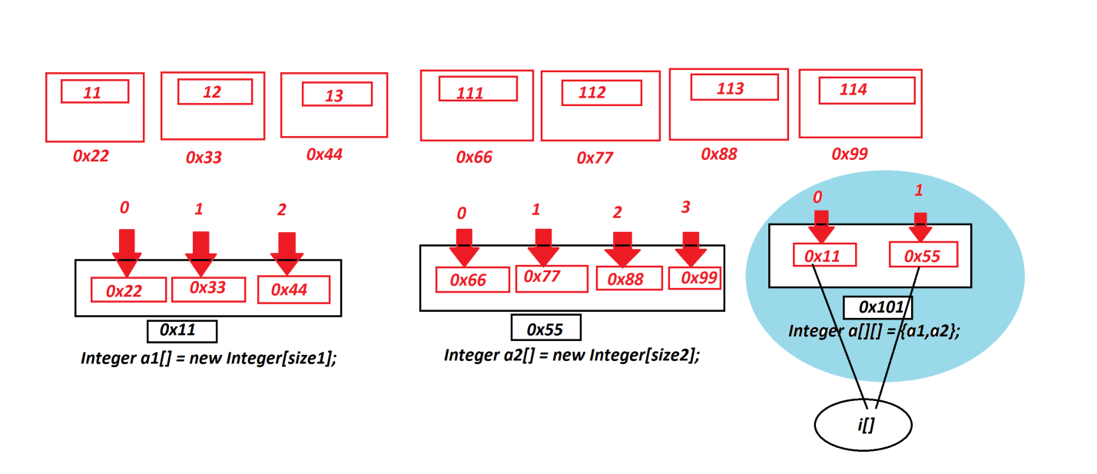

***Ex : DemoArray6.java***

***package maccess;***

***import java.util.*;***

***public class DemoArray6 {***

***@SuppressWarnings("removal")***

***public static void main(String[] args) {***

***Scanner s = new Scanner(System.in);***

***System.out.println("Enter size of Array-1:");***

***int size1 = s.nextInt();***

***Integer a1[] = new Integer[size1];***

***System.out.println("Enter "+size1+" elements for Array-1");***

***for(int i=0;i<size1;i++)***

***{***

***a1[i] = new ~~Integer~~(s.nextInt());***

***}//end of loop***

***System.out.println("Enter size of Array-2:");***

***int size2 = s.nextInt();***

***Integer a2[] = new Integer[size2];***

***System.out.println("Enter "+size2+" elements for Array-2");***

***for(int i=0;i<size2;i++)***

***{***

***a2[i] = new ~~Integer~~(s.nextInt());***

***}//end of loop***

***Integer a[][] = {a1,a2};//Jagged_Array***

***System.out.println("====Display from Jagged Array====");***

***for(Integer i[] : a) {***

***System.out.print("Array : ");***

***for(Integer j : i) {***

***System.out.print(j.toString()+" ");***

***}//InnerLoop***

***System.out.println();***

***}//OuterLoop***

***}***

***}***

***o/p:***

***Enter size of Array-1:***

***3***

***Enter 3 elements for Array-1***

***11***

***12***

***13***

***Enter size of Array-2:***

***4***

***Enter 4 elements for Array-2***

***111***

***112***

***113***

***114***

***====Display from Jagged Array====***

***Array : 11 12 13***

***Array : 111 112 113 114***

***======================================================***

***faq:***

***define Object Array?***

***=>The Array which is declared with 'java.lang.Object' class is***

***known as Object Array.***

***syntax:***

***Object o[] = new Object[size];***

***Advantage:***

***=>Object Array can hold Dis-similer objects,which means objects***

***of different classes.***

***Ex : DemoArray7.java***

***package maccess;***

***import test.Product;***

***public class DemoArray7 {***

***@SuppressWarnings("removal")***

***public static void main(String[] args) {***

***Object o[] = new Object[3];***

***o[0] = new ~~Integer~~(123);//Integer Object***

***o[1] = new String("NIT-HYD");//String Object***

***o[2] = new Product("A001","CJ",1200,12);***

***//User defined Class Object***

***System.out.println("====Object Array====");***

***for(Object k : o)***

***{***

***System.out.println(k.toString());***

***}//end of loop***

***}***

***}***

***o/p:***

***====Object Array====***

***123***

***NIT-HYD***

***A001 CJ 1200.0 12***

***=========================================================***